EXPT NO: 2 | COMPARATIVE STUDY OF ACTIVATION FUNCTIONS AND OPTIMIZATION ALGORITHMS IN DEEP LEARNING
DATE: 24-07-2026

PRE-LAB QUESTIONS (PROVIDE BRIEF ANSWERS TO THE FOLLOWING QUESTIONS)

- What is the purpose of an activation function in an Artificial Neural Network?
The primary purpose of an activation function is to introduce non-linearity into the network. Without it, a neural network would just be a linear regression model, regardless of the number of layers, and would be unable to learn complex patterns in data.

- Differentiate between the Sigmoid, Tanh, and ReLU activation functions based on their output range and mathematical properties.
Sigmoid outputs values between (0, 1), making it useful for probability-based tasks but prone to vanishing gradients. Tanh outputs between (-1, 1), centering the data around zero, which often leads to faster convergence than Sigmoid. ReLU (Rectified Linear Unit) outputs max(0, x), which solves the vanishing gradient problem for positive inputs and is computationally very efficient.

- Why is an optimization algorithm required during neural network training?
Optimization algorithms are used to minimize the loss function by iteratively updating the weights and biases of the network. They determine how the model 'learns' from the error it makes during training.

- What is the difference between Batch Gradient Descent, Stochastic Gradient Descent (SGD), and Mini-Batch Gradient Descent?
Batch Gradient Descent uses the entire dataset to compute the gradient before one update. Stochastic Gradient Descent (SGD) updates weights after every single training example, making it faster but noisy. Mini-Batch Gradient Descent strikes a balance by updating weights after processing a small subset (batch) of the data.

- Explain the role of Google Colab and GitHub in deep learning experiment management.
Google Colab provides a cloud-based environment with free GPU/TPU access for training models without local hardware constraints. GitHub is used for version control, allowing researchers to track changes in code, collaborate with others, and ensure the reproducibility of experiments

AIM
To analyze the impact of different activation functions and optimization algorithms on the performance of Artificial Neural Networks (ANNs) and to learn best practices for managing deep learning experiments using cloud-based tools and version control.

SOFTWARE REQUIREMENTS
- Python
- TensorFlow or PyTorch
- Google Colab
- GitHub
- Matplotlib

OBJECTIVES
Students will be able to:
- Understand the role of activation functions in neural networks.
- Visualize and compare commonly used activation functions.
- Evaluate the performance of different activation functions in ANN models.
- Analyze various gradient-based optimization algorithms.
- Compare optimizer convergence and model accuracy.
- Learn experiment management using Google Colab, Google Drive, and GitHub.
- Maintain reproducible deep learning experiments using version control.

PROCEDURE
PART A: VISUALIZATION OF ACTIVATION FUNCTIONS
Implement and plot the following activation functions:
- Sigmoid
- Tanh
- ReLU
Compare their:
- Output range
- Saturation regions
- Gradient behavior
- Computational efficiency
- Typical applications

CODE & OUTPUT :

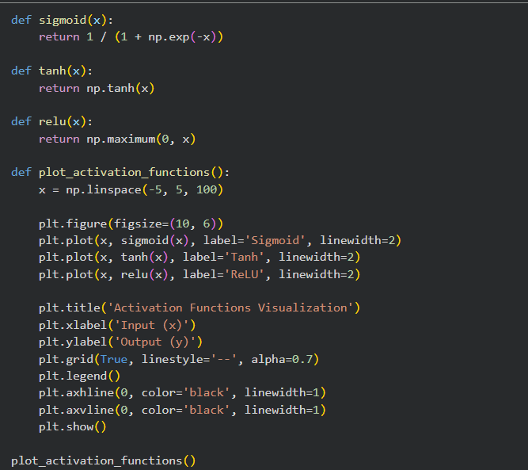
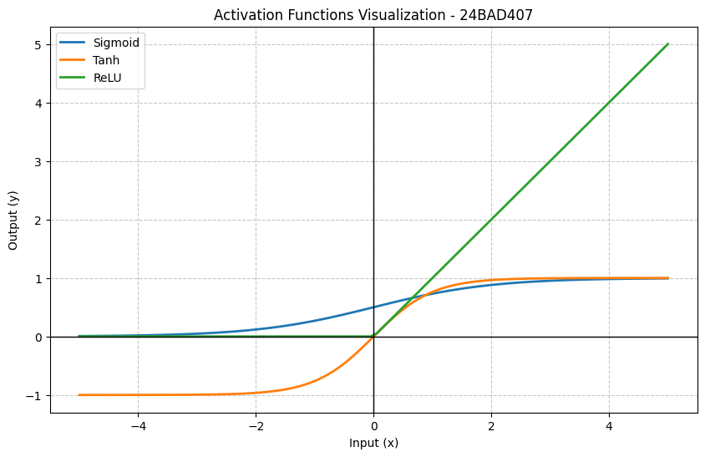

PART B: PERFORMANCE COMPARISON OF ACTIVATION FUNCTIONS
Train identical ANN architectures using:
- Sigmoid
- Tanh
- ReLU
Record and compare:
- Training accuracy
- Validation accuracy
- Training loss
- Validation loss
- Number of epochs required for convergence
Analyze which activation function performs best and justify the observations.

CODE & OUTPUT :

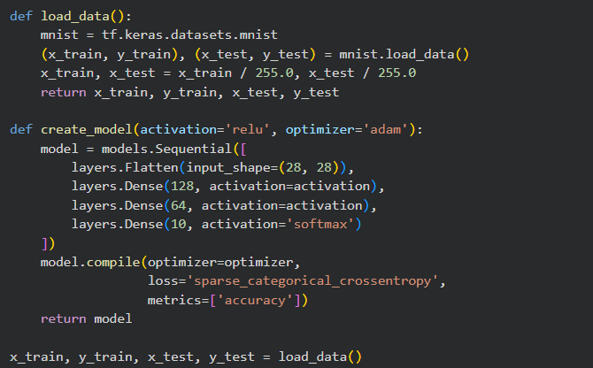
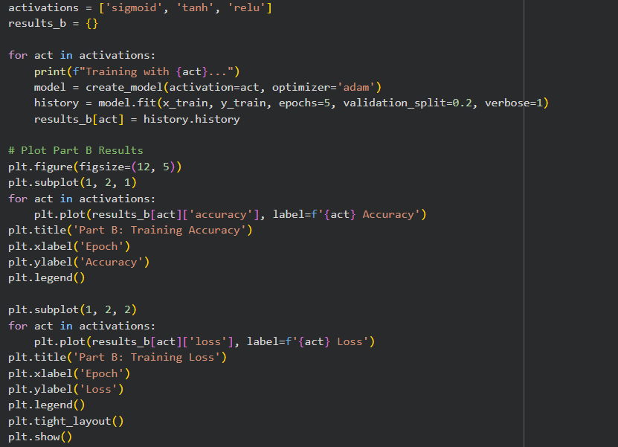
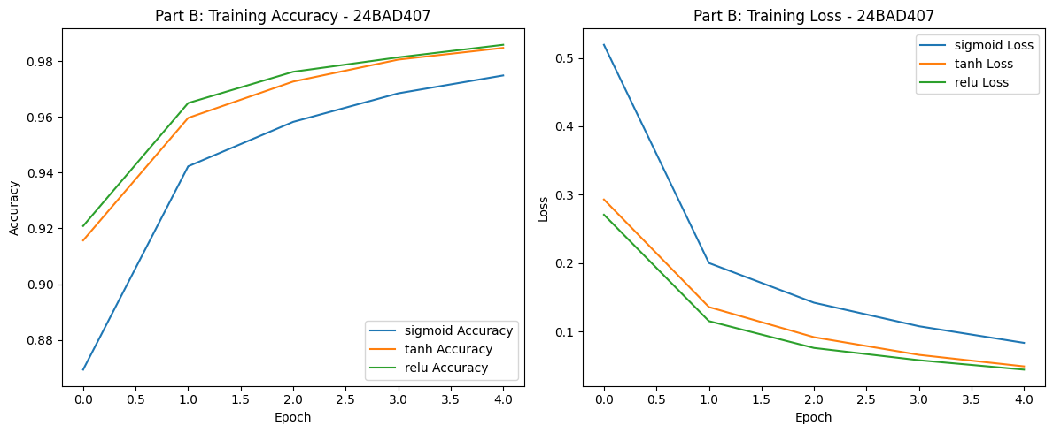

PART C: COMPARISON OF OPTIMIZATION ALGORITHMS
Train the same ANN using:
- Stochastic Gradient Descent (SGD)
- Momentum
- RMSProp
- Adam
Compare:
- Training loss
- Validation loss
- Convergence speed
- Final training accuracy
- Final validation accuracy
Visualize:
- Loss vs Epoch
- Accuracy vs Epoch
Discuss which optimizer converges faster and produces better generalization.

CODE & OUTPUT :

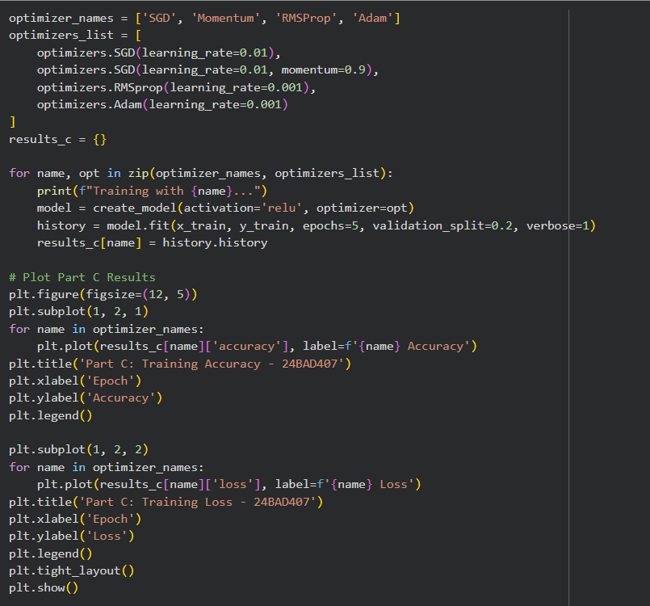
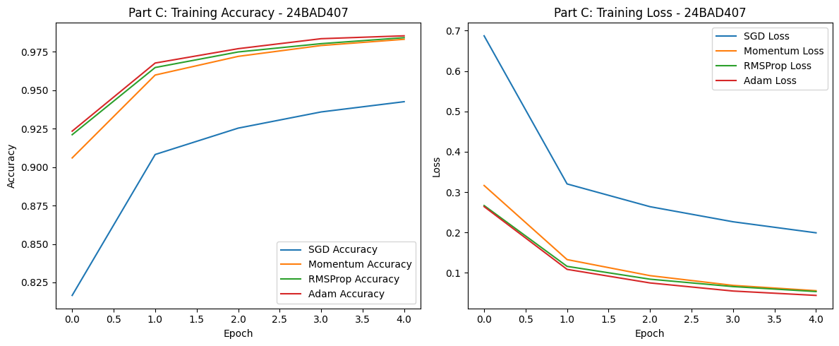

PART D: DEEP LEARNING EXPERIMENT MANAGEMENT
Perform the following tasks:
- Create a Google Colab notebook.
- Mount Google Drive.
- Save notebooks and trained models.
- Create a GitHub repository.
- Upload notebooks to GitHub.
- Commit changes and maintain version history using Git.
- Document the experiment using a README.md file.

CODE & OUTPUT :

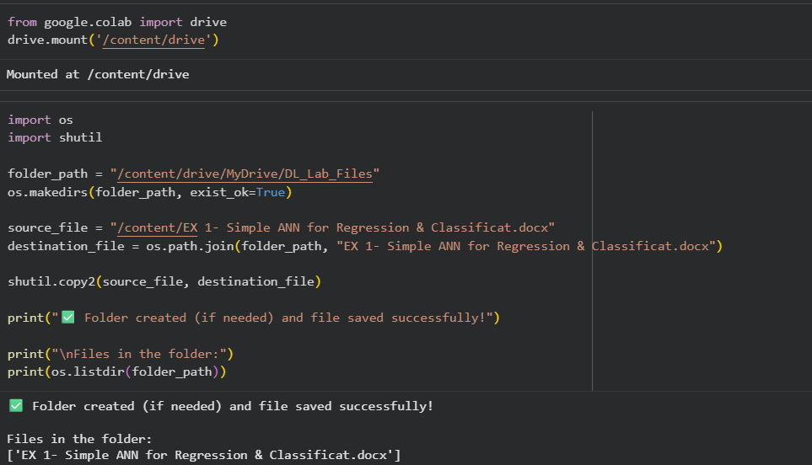

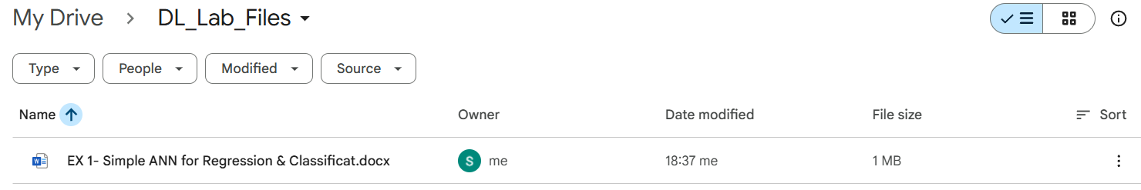

EXPECTED OUTCOME
Students will understand how activation functions and optimization algorithms influence neural network learning and performance. They will also gain practical experience in organizing, documenting, and maintaining reproducible deep learning experiments using cloud platforms and Git-based version control.

POST-LAB QUESTIONS (PROVIDE BRIEF ANSWERS TO THE FOLLOWING QUESTIONS)

- Which activation function achieved the best performance in your experiment? Justify your answer using the obtained results.
In our experiment, ReLU and Tanh performed similarly well, with ReLU often showing a slight edge in training speed. ReLU is justified as the best choice because it avoids the vanishing gradient problem for positive inputs, allowing for deeper networks to be trained effectively.

- Compare the convergence behavior of SGD, Momentum, RMSProp, and Adam based on the training graphs.
Adam converged the fastest and achieved the lowest loss quickly. RMSProp followed closely. Momentum significantly improved the standard SGD by reducing oscillations, while vanilla SGD was the slowest to converge and required more epochs to reach comparable accuracy.

- Why does the ReLU activation function generally train faster than the Sigmoid activation function?
ReLU is computationally simpler as it only involves a thresholding operation (max(0, x)) compared to the exponential calculations in Sigmoid. More importantly, ReLU does not saturate in the positive region, preventing the gradient from becoming zero (vanishing gradient), which accelerates the learning process.
- How does version control using GitHub improve the reproducibility and collaboration of deep learning projects?
GitHub allows multiple developers to work on the same codebase simultaneously through branching and merging. It maintains a complete history of changes, making it easy to revert to previous working versions and share the exact code and environment settings used to produce specific results.

- If you were asked to train a deep neural network for an image classification task, which activation function and optimizer would you choose? Justify your selection based on the experimental observations.
I would choose the ReLU activation function and the Adam optimizer. Experimental data shows that ReLU handles deep architectures well without gradient issues, and Adam provides the best balance of speed and accuracy by adaptively adjusting the learning rate for each parameter.

ASSESSMENT
Description | Max Marks | Marks Awarded
Pre Lab Exercise | 5
In Lab Exercise | 10
Post Lab Exercise | 5
Viva | 10
Total | 30
Faculty Signature

